**Experiment No # 03**

**Experiment Name # Connecting database (Mysql) with Linux.**

**Aim and Objects:**

Here, we will see that how to run MySQL in Linux Ubuntu Operating System. This Linux MySQL Client Installation Guide assumes that we have already installed MySQL Server on Linux Machine. the results of those commands :

#### 1): Execute MySQL Client :

Type the following command to Start or Run MySQL Database Client :

Command : mysql -u root -p

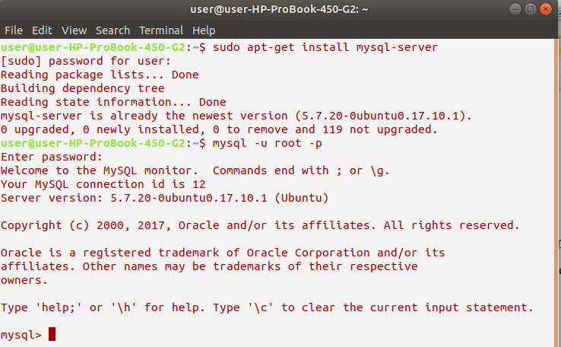

#### 2): Create A New MySQL Database

Now, we will have to Create a New Database in MySQL Database since it does not have any default database. We can make use of the following command to Create a New Database in MySQL.

Command: create database database_name;

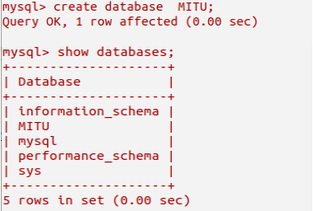

#### 3): Execute The New Linux MySQL DB

Now we have Logged into the New Database, we have to Tell the Linux Terminal or the MySQL Database Client about the Database that we want to use. This command will help to Run MySQL in Linux Ubuntu.

Command: use database_name;



#### 4: Create A New MySQL Table

We have to first create a Table in Newly created MySQL Database. We can use the following command :

#### 

#### 5: View The Table Schema

To Check if the Table has been successfully created or not, we can check it with the Describe Command.

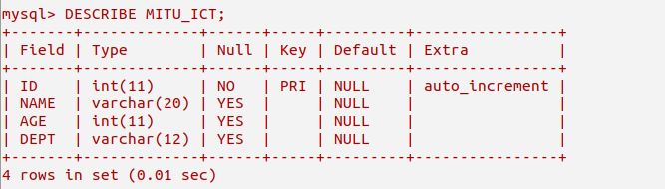

#### 6: Insert Values into Database Table

To Insert Data or Values into the Database Tables, we can use the Insert Command :



**7: View The Table Contents**

After we have used Insert Command to Input Data in the Database, ywe can check and verify for the Data Items in the Database Tables with the following Select Command :

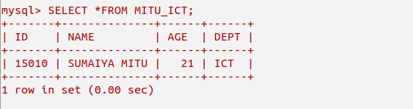

**Conclusion:**

Hope that this report Run MySQL in Linux Ubuntu using command line help us to Install MySQL Database in Linux OS successfully. After installing we will be able to create database table and can perform the database operations.